AE2 camera error

Each screenshot is the camera moving forward

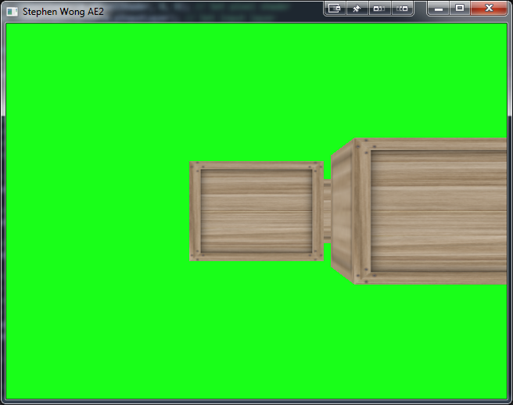

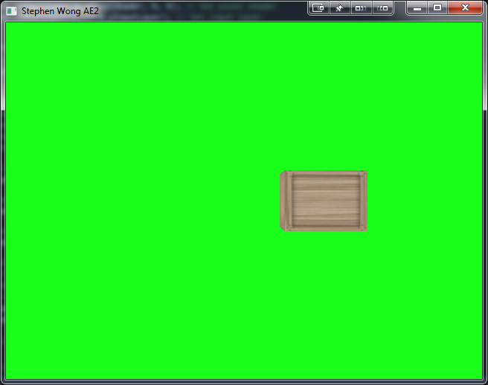

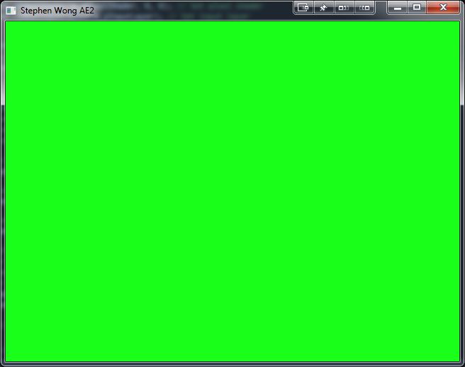

Pause Menu button

Screen to client, the yellow box shows where the resume button is pressed when clicked. The exit button could not be pressed

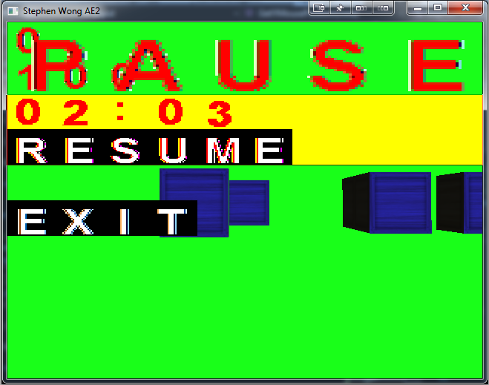

Using these, blue = exit

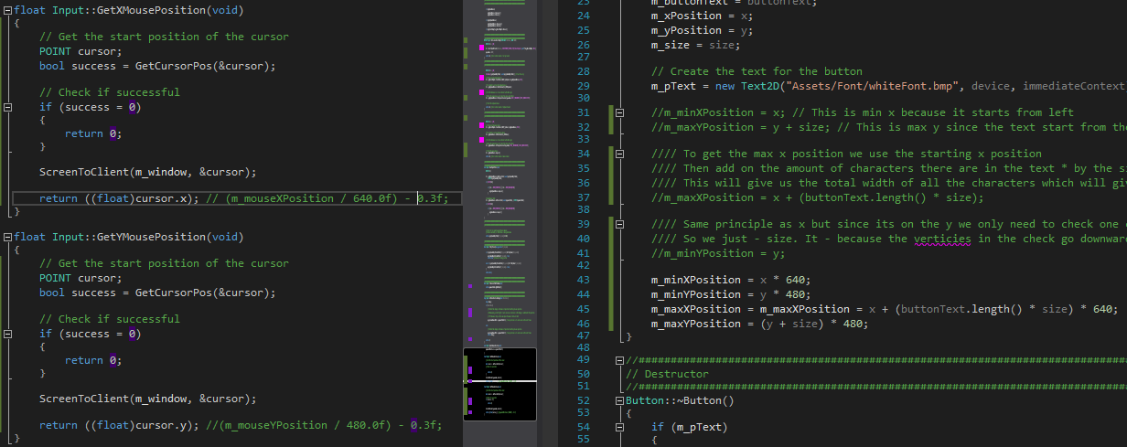

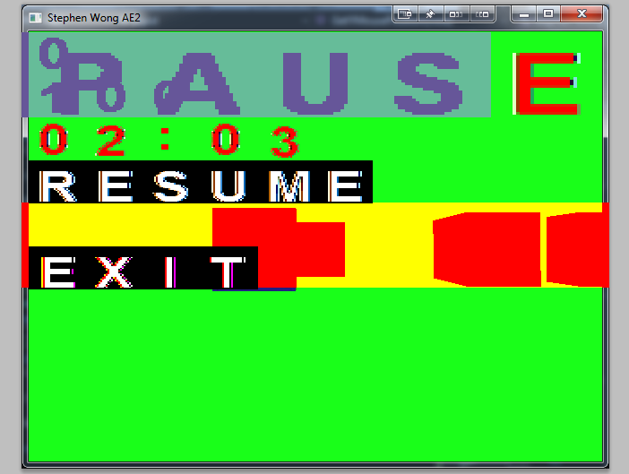

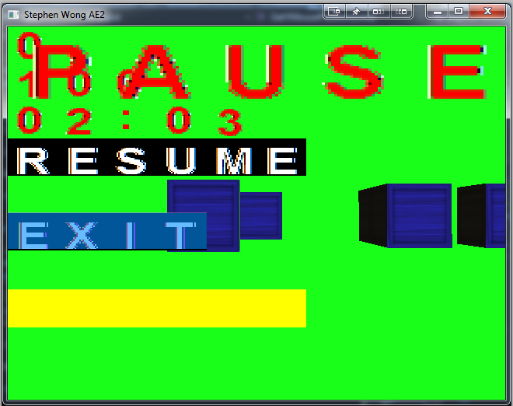

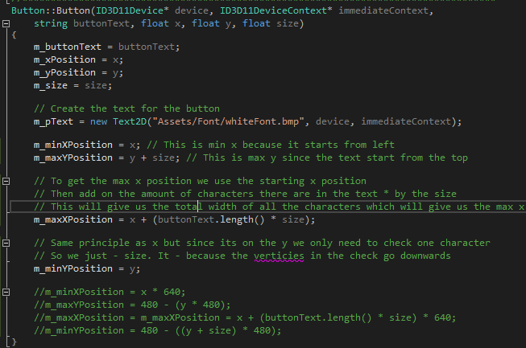

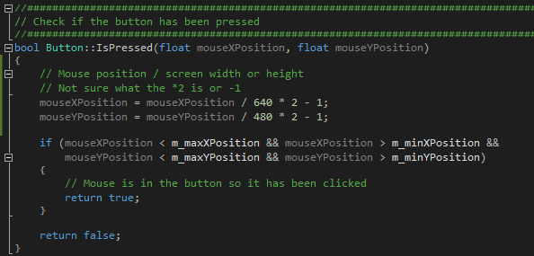

Working correctly:

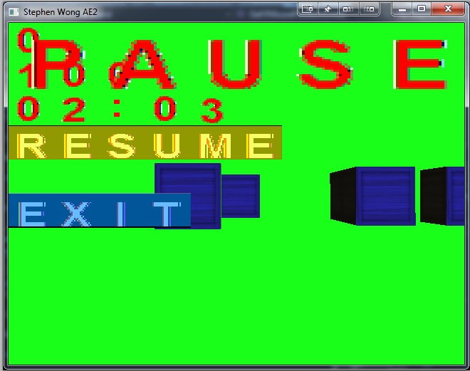

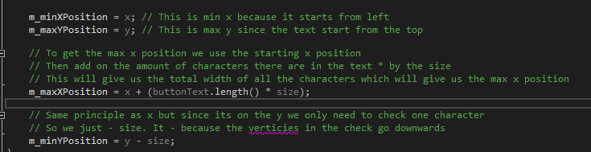

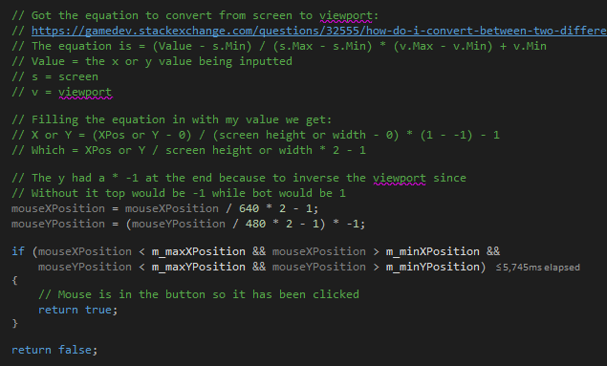

Memory leak on game over, fix was to check if the game over screen had been created and if so don’t make it since it was creating it every frame

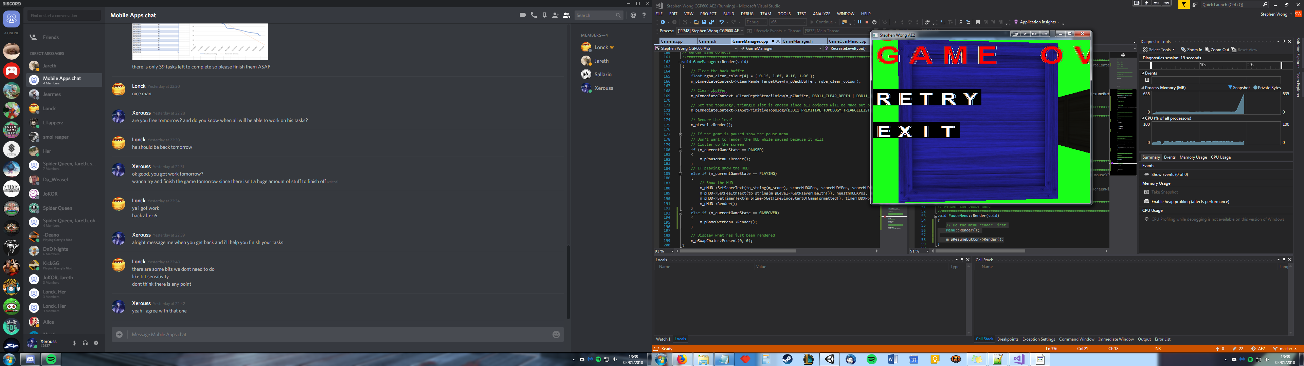

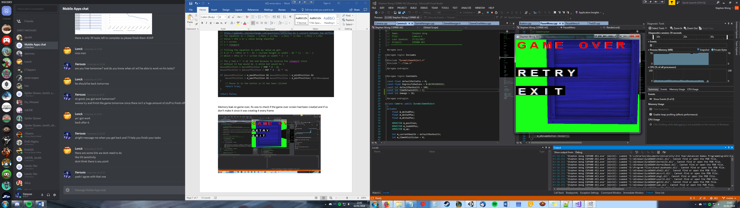

SQRT between 3 and 7 ms

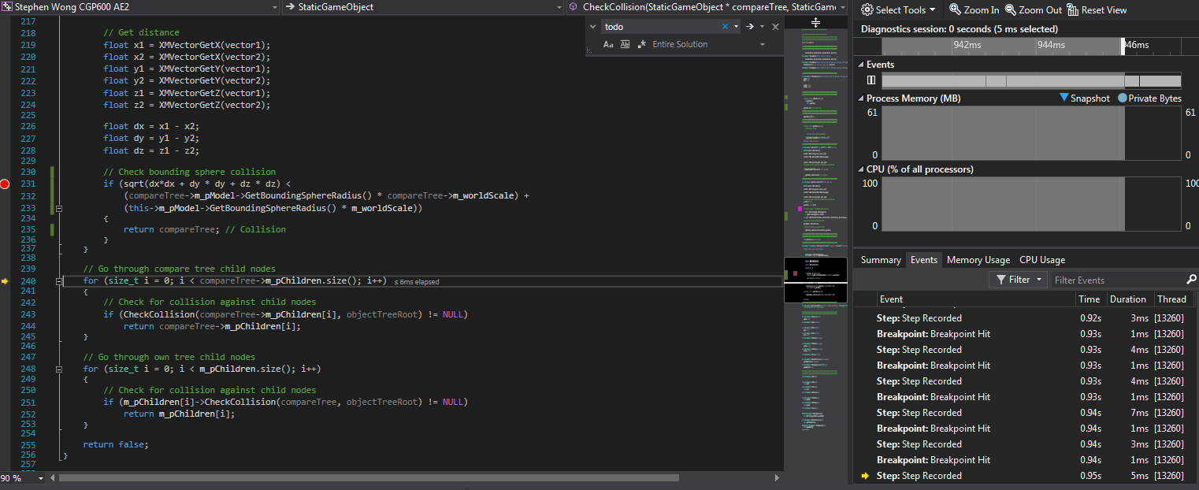

When using ^2 on the other side it changed to 3ms

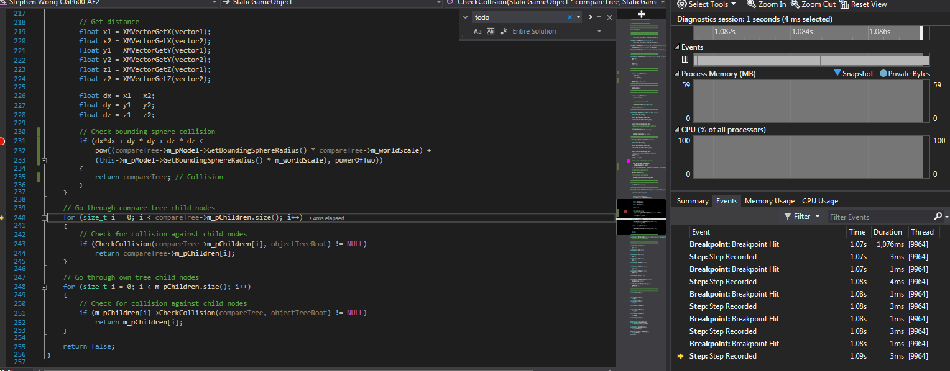

Pause without creating/deleting on the fly – constant 88.9mb

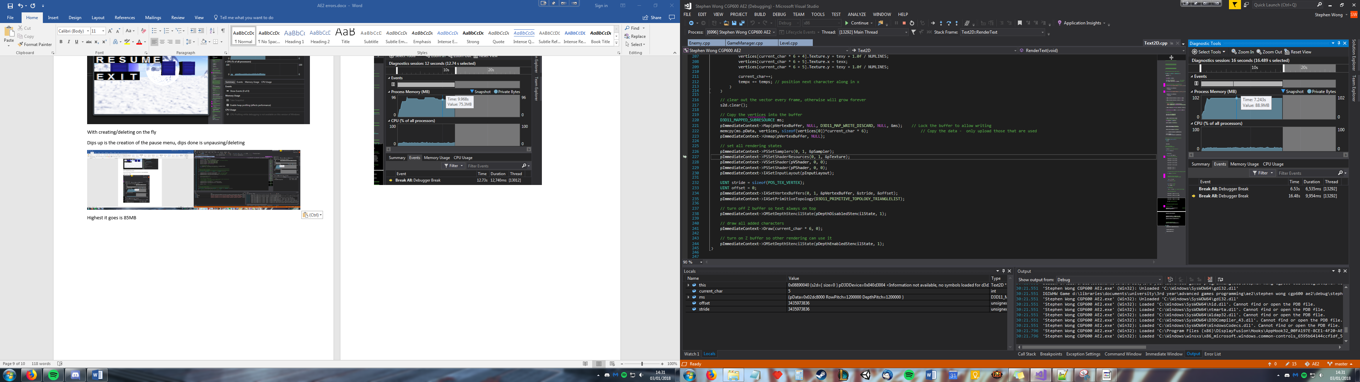

With creating/deleting on the fly

Dips up is the creation of the pause menu, dips done is unpausing/deleting, it varies how much MB uses up, highest I’ve seen is 92.2M but is normally uses much less memory then just creating it at the start of the game.

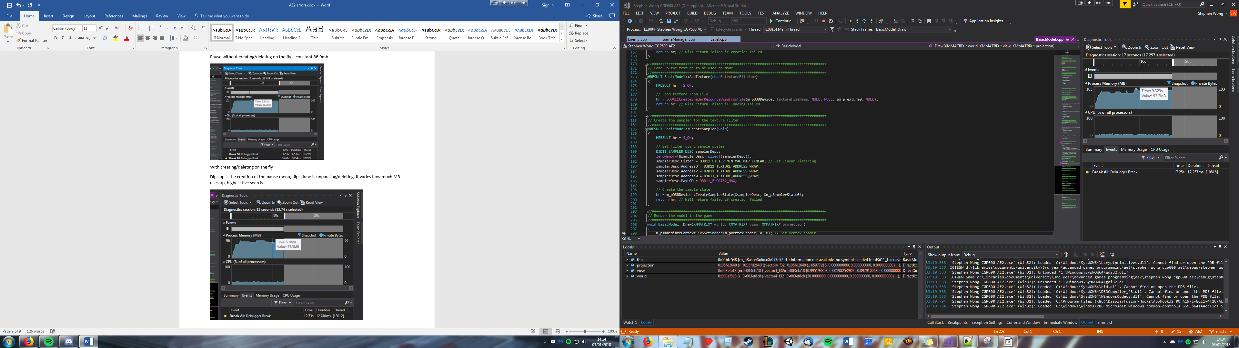

Can be lower such as this was 79MB

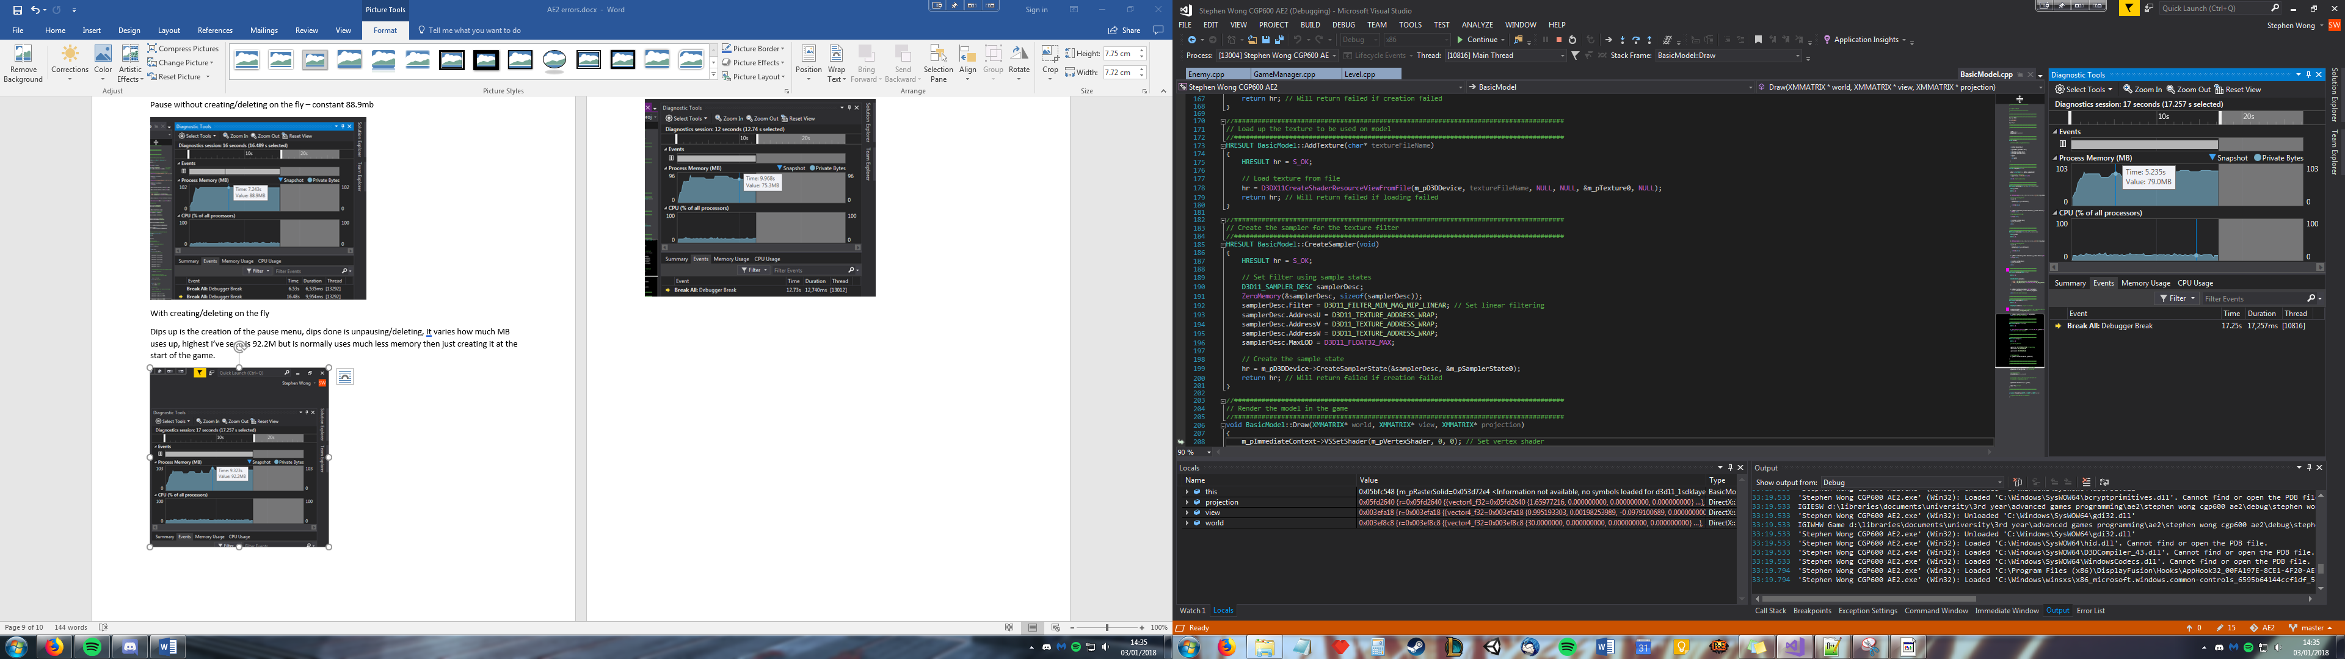

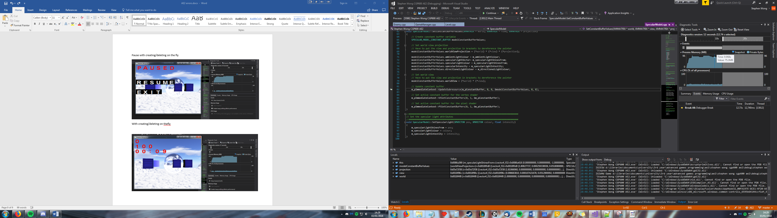

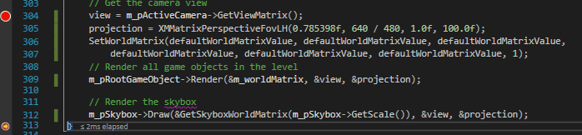

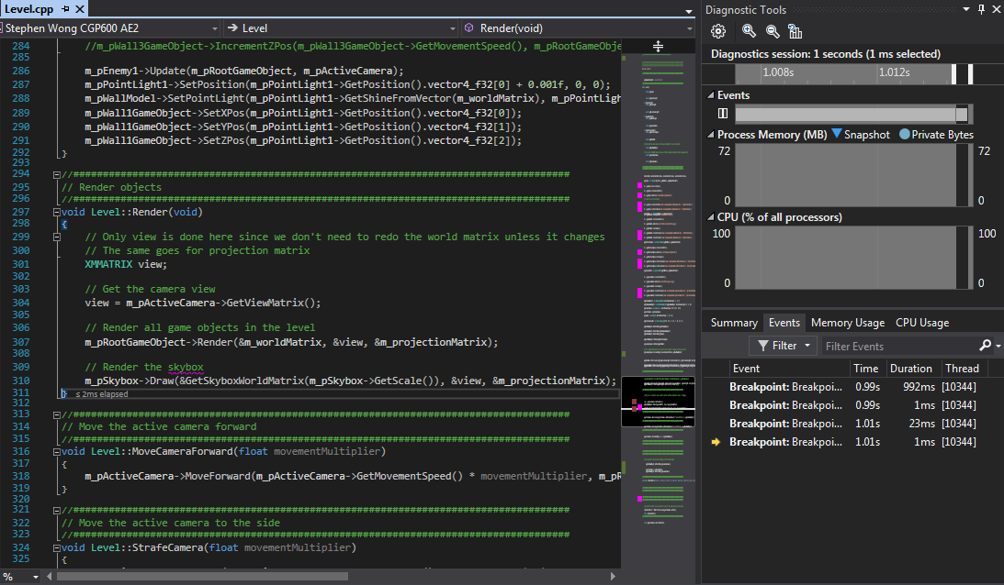

Uses up slightly more memory when calculating the projection and world matrix in render

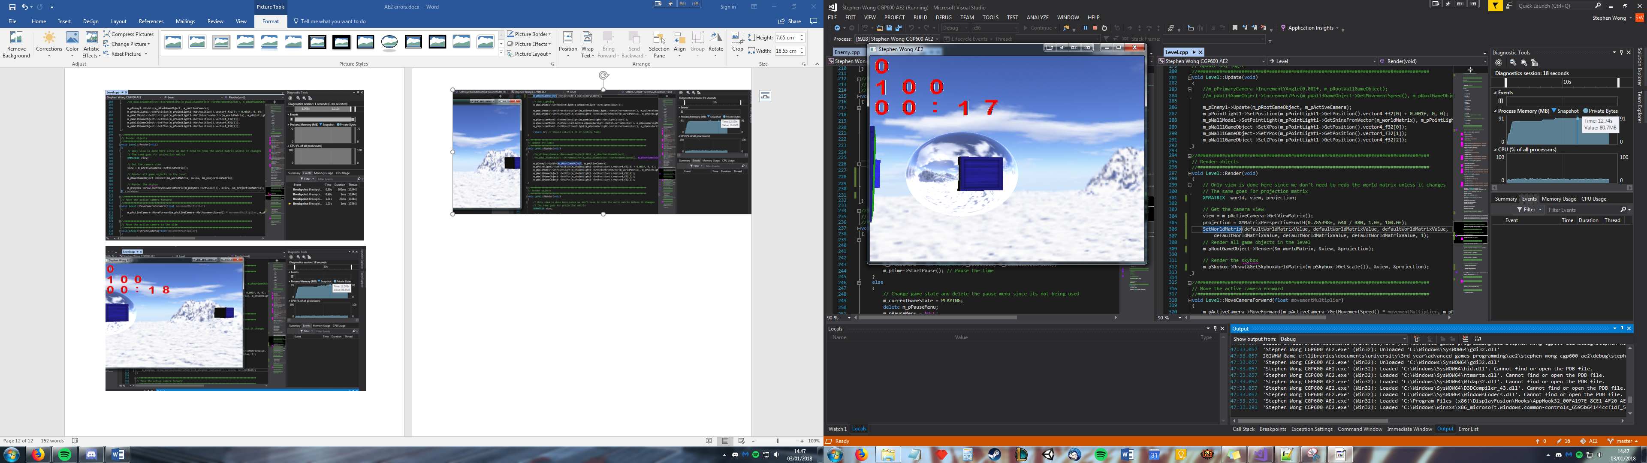

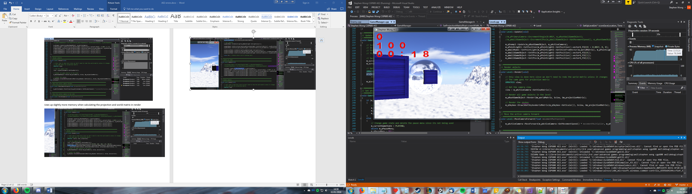

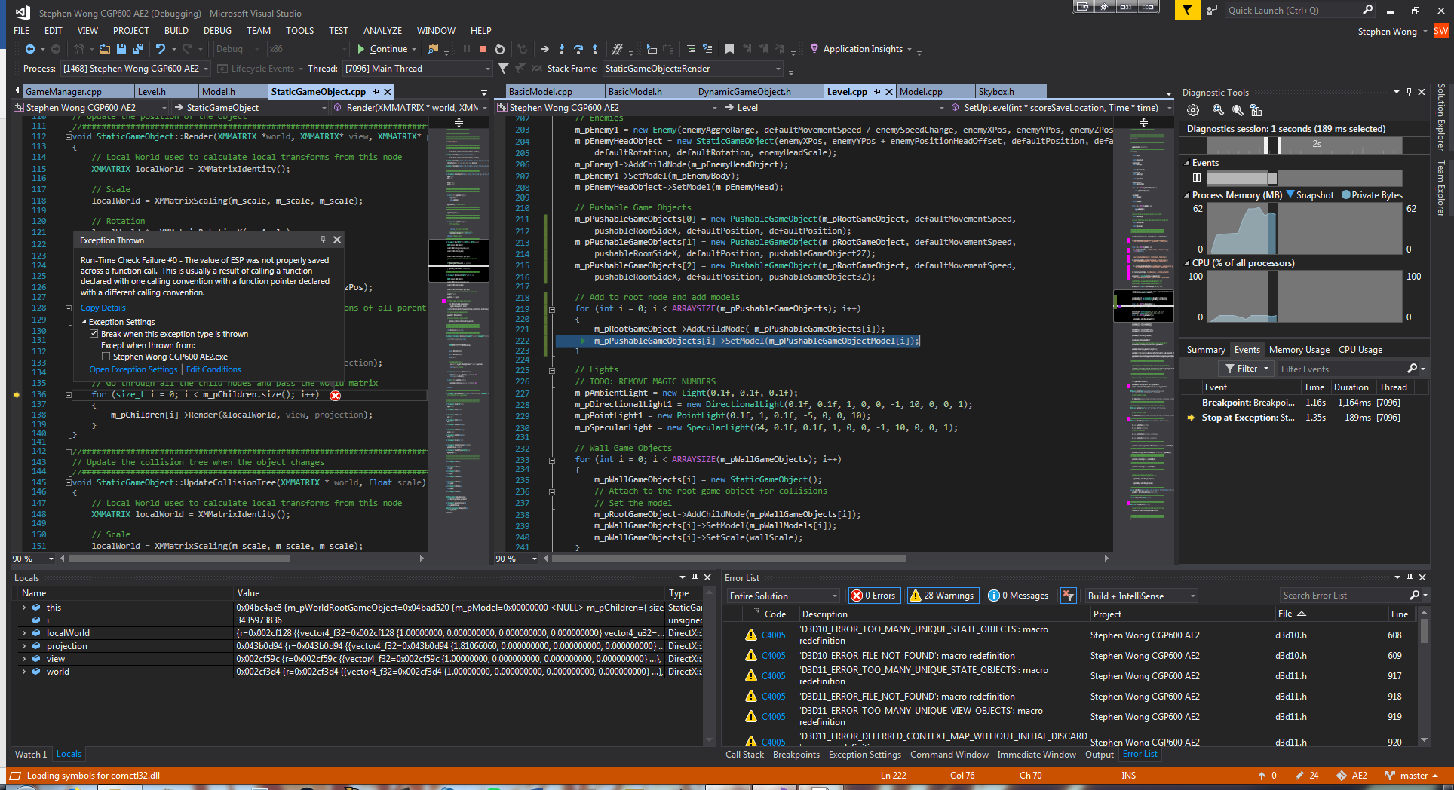

Error was due to me creating 3 objects when the array size was 2